**Agile Vs. Waterfall: Which Project Management Methodology Is Best For You?**

[](https://www.forbes.com/advisor/author/lhoory/)

Written By

[**Leeron Hoory**](https://www.forbes.com/advisor/author/lhoory/)

Contributor

[Cassie Bottorff](https://www.forbes.com/advisor/author/cbottorff/)

Written By

[**Cassie Bottorff**](https://www.forbes.com/advisor/author/cbottorff/)

Editor

[](https://www.forbes.com/advisor/author/rob-watts/)

[**Rob Watts**](https://www.forbes.com/advisor/author/rob-watts/)

**Reviewed**

|Managing Editor, SMB

Updated: May 31, 2024, 8:19pm

Editorial Note: We earn a commission from partner links on Forbes Advisor. Commissions do not affect our editors' opinions or evaluations.

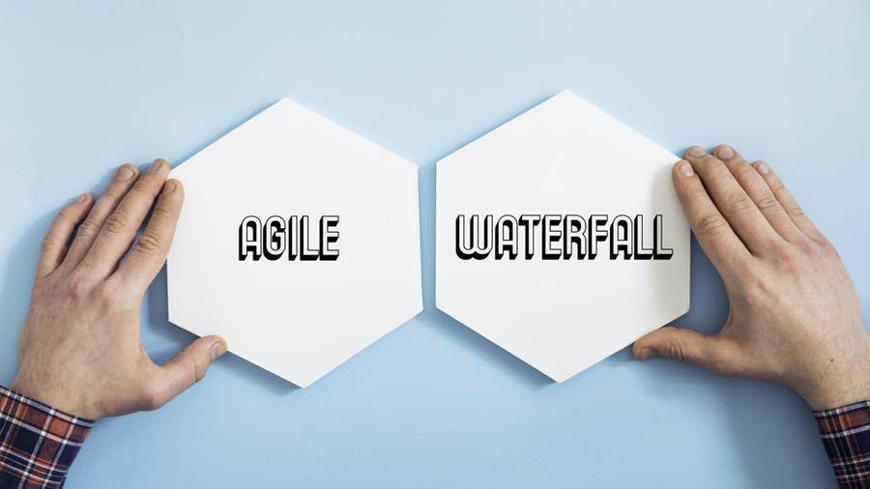Getty

Agile and Waterfall are two well-known project management methodologies. Both of them are popular in software development but each is best suited for different types of projects. The main difference is that Waterfall is a linear system of working that requires the team to complete each project phase before moving on to the next one while Agile encourages the team to work simultaneously on different phases of the project.

**Featured Partners**

Advertisement

Free version available

Yes

Starting price

From $8 monthly per user

Integrations

Zoom, LinkedIn, Adobe, Salesforce and more

1

**monday.com**

[monday.com](https://monday.com/ap/project-management?utm_medium=affiliates&utm_source=USbrands&utm_adgroup=forbes_wm-organic&utm_campaign=multi-multi-prm-work_mgmt&utm_banner=FA4c456dcec8a1b01e1fb5f2fdadfebd81_PWwVDNwjTCN9)

[**Learn More**](https://monday.com/ap/project-management?utm_medium=affiliates&utm_source=USbrands&utm_adgroup=forbes_wm-organic&utm_campaign=multi-multi-prm-work_mgmt&utm_banner=FA4c456dcec8a1b01e1fb5f2fdadfebd81_2SFPJz31nSH5)

On monday.com's Website

Free version available

Yes, for one user and two editors

Starting price

$9 per user per month

Integrations

Google Drive, Slack, Tableau, Miro, Zapier and more

2

**Smartsheet**

[Smartsheet](https://mktp.us/smartsheet-pm)

[**Learn More**](https://mktp.us/smartsheet-pm)

On Smartsheet's Website

Free version available

Yes, for unlimited members

Starting price

$7 per month

Integrations

Slack, Microsoft Outlook, HubSpot, Salesforce, Timely, Google Drive and more

3

**ClickUp**

[](https://clickup.pxf.io/c/1955282/1461580/16855?subid1=FA4c456dcec8a1b01e1fb5f2fdadfebd81_VDZs1c8njvOk&subid2=%2Fadvisor%2Fbusiness%2Fagile-vs-waterfall-methodology%2F)

[**Learn More**](https://clickup.pxf.io/c/1955282/1461580/16855?subid1=FA4c456dcec8a1b01e1fb5f2fdadfebd81_tqFdoDFRzfka&subid2=%2Fadvisor%2Fbusiness%2Fagile-vs-waterfall-methodology%2F)

On ClickUp's Website

Free version available

Yes

Starting price

$9.80 per user per month

Integrations

Salesforce, Adobe, Miro, Netsuite, Quickbooks, SAP

4

**Wrike**

[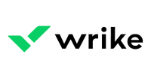](https://mktp.us/Wrike)

[**Learn More**](https://mktp.us/Wrike)

On Wrike's Website

**Agile vs. Waterfall: At a Glance**

**Agile Methodology**

* **Approach:** Frequent stakeholder interaction
* **Flexibility:** High
* **Requires:** Team initiative and short-term deadlines

[Agile methodology](https://www.forbes.com/advisor/business/what-is-agile-project-management/) was developed as a response to Waterfall’s more rigid structure. As a result, it’s a much more fluid form of project management. A software development project can take years to complete, and technology can change significantly during that time. Agile was developed as a flexible method that welcomes incorporating changes of direction even late in the process, as well as accounting for stakeholders’ feedback throughout the process.

In Agile, the team will work on phases of the project concurrently, often with short-term deadlines. Additionally, the team, rather than a project manager, drives the project’s direction. This can empower the team to be motivated and more productive, but also requires a more self-directed team.

| **Pros** | **Cons** |
| --- | --- |
| Short-term deadlines encourage productivity and efficiency | Because team members are working on multiple phases at a time, there is potential for overlap or unnecessary effort spent on later stages if an early phase needs to be modified |
| There is a lot of flexibility to change project direction and experiment with new directions | Deliverables are not a requirement to progress to the following phase. It can be harder to ensure the entire team is on the same page—especially if it’s a large team with different departments. It also means that work can get lost or miscommunicated between team members, especially when people leave and join the team in the middle of the projects. |
| The methodology is client-facing, which means that the team shares progress and incorporates feedback into the process | The project timeline is more difficult to determine from the start, and it is also more susceptible to change |

**Waterfall Methodology**

* **Approach:** Hands-off; goals and outcome established from the beginning
* **Flexibility:** Low
* **Requires:** Completing deliverables to progress to the next phase

[Waterfall methodology](https://www.forbes.com/advisor/business/what-is-waterfall-methodology/) is a linear form of project management ideal for projects where the end result is clearly established from the beginning of the project. The expectations for the project and the deliverables of each stage are clear and are required in order to progress to the next phase.

| **Pros** | **Cons** |
| --- | --- |
| Provides a concrete plan of the project from start to finish | Because each project phase needs to be completed before progressing to the next stage, the process can take longer |
| The team establishes project requirements early on, which can save time | You might not realize an issue with a phase until you have already progressed to the next one. This would mean going back through each phase and checking where the mistake or error occurred, which can be a timely process. |
| Each phase of the project requires a deliverable to progress to the next phase, making the workflow more structured | The Waterfall methodology requires that you outline the project from start to finish before you begin. This doesn't allow for a lot of flexibility or change. Additionally, it can become problematic if the stakeholders disagree on the project’s vision and don’t find out until it is executed or in a later phase. |

**Agile and Waterfall Comparison Chart**

|  | **Waterfall** | **Agile** |
| --- | --- | --- |
| Timeline | Waterfall has a fixed timeline. The idea is that the start and finish of the project are already mapped out from the beginning. | Agile is a lot more flexible and accounts for experimenting with different directions. Rather than a fixed timeline, the schedule adapts as the project progresses. The [Agile Manifesto](http://agilemanifesto.org/principles.html), an online document released in 2001 by a group of software developers, says team members are expected to, “​​Deliver working software frequently, from a couple of weeks to a couple of months, with a preference to the shorter timescale.” |
| Client Involvement | Once the end goal is established, Waterfall does not involve the client or project owner during the process, apart from specific check-ins or for deliverables. The course of the project is outlined from the start, so incorporating client feedback is not an ongoing part of the process. | A fundamental part of Agile is including clients in the project development at every step. The Agile Manifesto states, “Our highest priority is to satisfy the customer through early and continuous delivery of valuable software.” Therefore, business owners are expected to be involved and give feedback to the software development team as they progress through the different phases of the project. |
| Flexibility | Waterfall is not as flexible as Agile because each phase needs to be fully completed before moving on to the next phase. The project is also planned out ahead of time, making this management system ideal for teams with a clear vision of where they are headed from start to finish. | Flexibility is built into the Agile method. Agile values short bursts of work, which are called sprints. The method welcomes adapting to different directions, incorporating new information even at a later stage of the project. |
| Budget | Fixed. The budget for projects using the Waterfall methodology is generally fixed. Because the project is determined from start to finish, there is less room to change the budget mid-project. | Flexible. Agile is open to adaptation, encourages experimentation and welcomes changes of direction, even in later phases of the project. Because of this, the budget tends to be more flexible. |

Waterfall is a linear project progression, so it’s best suited for projects with a defined end goal. If a project owner has a clear and specific vision of an app, for example, and is confident it will not change throughout the project development, Waterfall methodologies could be a good system to follow.

Meanwhile, Agile leaves a lot of room to adapt and change course as the project develops. It’s better suited for projects where the outcome may be dependent on more research or testing.

The budget for projects using Waterfall methodologies tends to be less flexible because the project is mapped out from the beginning. With Agile, there is more room to change direction as the project develops, so the budget is also subject to change. Similarly, the timeline with Waterfall is set from the start, while it’s more flexible with Agile and dependent on how the project develops.

**Waterfall vs. Agile: How To Choose the Right Methodology for Your Project**

There are several factors to consider when you are choosing between Waterfall and Agile. Here are a few questions to consider:

Does your project require strict regulations or requirements? Waterfall is better suited for projects with regulations or requirements because each phase’s deliverables and strict procedures ensure that they are met. For instance, the Department of Defense and the aerospace industry are a couple of industries that would more likely use Waterfall over Agile, since the requirements are a safety factor. [Dr. Chris Mattmann](https://www.mattmann.ai/), Chief Technology and Innovation Officer (CTIO) at NASA Jet Propulsion Laboratory, told Forbes Advisor that “agile methodology is used more for IT companies, [companies] that fail fast and move fast, types of places where you can proceed in parallel in different phases.”

When choosing between Agile and Waterfall, consider how involved the project owners or stakeholders will be in the project. Agile is better suited for projects where stakeholders are closely involved every step of the way. Waterfall is a more structured project management method and does not lend itself to the same type of flexibility.

**Bottom Line**

To summarize, Agile and Waterfall are two different management methodologies best suited for different types of projects. If you clearly understand the project outcomes from the beginning, Waterfall may be the best fit. Waterfall is a better method when a project must meet strict regulations as it requires deliverables for each phase before proceeding to the next one.

Alternatively, Agile is better suited for teams that plan on moving fast, experimenting with direction and don’t know how the final project will look before they start. Agile is flexible and requires a collaborative and self-motivated team, plus frequent check-ins with business owners and stakeholders about the progress.